**AGRICULTURE & FOOD PRODUCTION**

In Partial Fulfillment of the Requirements for the Degree Bachelor of Science in

Information Technology

Submitted By:

Baet, Jaspher D.

Buladaco, Jaime D.

Caravana, Charie D.

Laviña, Anthony Nathaniel V.

Marquez, Clarestter Dhuke R.

Vargas, Joanvic S.

Submitted to;

Ed Dela Cruz Jr. MIT

December 2023

**INTRODUCTION**

The farm agriculture is a Farmer centric website whereas this helps them to market their own goods in a modernized way. This website also helps consumers to find the fresh and quality products straight from the farmland by purchasing directly on it, in this way farmers don't have any platform for the business part since the website already offers it.

The websites have 2 major parts and the first part targets audiences like Local government units (LGU) and product consumers since the 1st layer of the website shows the projects of the Farm Agriculture and farmers products that helps the farmers grow on what they do for living while making sure that they’re well compensated. The projects that the Farm agriculture supports were shown as well to seek for support to our farmers to make the agricultural industry elevated and not neglected, due to the reason that this is an important sector of our society too.

The 2nd part of the website was also to help the productivity of our farmers since on this part they can Log in to their accounts and track the progress of their sales and inventory which is necessary since the items purchased on the 1st part of the website was well tracked on this part.

In terms of scope, the website offers a convenient user experience for browsing and purchasing fresh and quality goods for the consumers which benefits both farmers and consumers this also offers convenience to the farmer perse as it’s offer 2 in 1 function that aims to efficiently make the task done and boost the productivity of our beloved farmers

**PROJECT OVERVIEW**

***PROJECT OBJECTIVE***

This project aims to integrate 2 major platforms that are essential for our farmers which is e – commerce and inventory management System. These platforms enable them to utilize and maximize the advancement of the key functions inside of these two platforms. Mainly to boost the productivity of their work efficiently and compete on the advanced market while supervising their own income and stocks.

***KEY FEATURES***

* **Navigation:** The website has a Responsive and well organized navigation menu, allowing users to easily access the menu bar with sub-menus such as home, about, product, service, log in and the categories of food crops under the products.
* **User Accounts:** Users can create a customer or owner account via sign up, Log in and access the features inside the website, such as exploring the menus, adding items on their cart, checking the services offered. Checking out the items on the cart.
* **User’s Contact Information:** The website requiring the user information, including the name, address, email, mobile number, and bank for payment.for both customer and owner to communicate with each other for their transaction
* **Product Listing:** The website features the different types of food crops, including the fruits, vegetable, cereals and seeds
* **Customer Engagement:** users can explore and ask about the website, and see the products that are being offered, leaving feedback for the purchase transaction regarding the satisfaction in terms of the services that are being picked.
* **Responsive Design:** The website appears to be a responsive to every features in menu bar including the product listing for a better experience

***TECHNOLOGIES USED***

* **Front-end Development:** HTML, CSS used for creating the Layout design or structure of the website together with the interactive elements.
* **Back-end Development:** JavaScript, Php and API Handle the server function and the interaction between database and website
* **Database Management:** MySQL for storing, organizing and managing the data related to product listing,user information, user account and future transactions
* **Responsive Design:** Implementationof responsive design using media queries to make the website compatible in different screen size of devices.
* **E-commerce Platform:**
* **Content Management System (CMS):**
* **Communication:** Integration of email and phone number as a form of contact ,notification and communication between customer and the seller.

**SYSTEM ARCHITECTURE**

***ARCHITECTURE OVERVIEW***

* **Front-end Development:** The homepage's user interface, design, and functionality likely utilize HTML, CSS. This encompasses the main features such as the home section, a page providing details about the website's history, mission, values, team members, and achievements. The products page showcases items available for purchase, including crops, fruits, vegetables, and livestock. The services page outlines the various offerings provided by the website. Additionally, there is a login page where users can sign in or create a new account. The crops page specifically exhibits the available crops, alongside vegetables, fruits, and livestock, highlighting the current inventory.
* **Back-end Development:** The interaction with the database, user attributes, and backend processes likely involve JavaScript, PHP and API usage. This encompasses the management of adaptive content, the functionality of buttons, and the provisioning of user accounts.
* **Database Management:** A database management system, such as MySQL, is likely integrated into the website, possibly using VS Code, Xampp and Myphp. This integration is intended to manage information related to agriculture, food production, user accounts, and customer satisfaction.
* **E-commerce Platform:** The website's management, product showcasing, and loan calculation functionality may be facilitated by integrating an e-commerce platform or an online marketplace into the website's infrastructure.
* **Responsive Design:** Currently, the website is exclusively compatible with PCs, with plans to introduce mobile compatibility in the upcoming phase. Despite this limitation, users still enjoy a seamless experience, emphasizing the website's smooth functionality
* **Content Management System (CMS):** To administer web pages containing product lists, services, and additional information, the website may be equipped with a content management system (CMS). This system facilitates efficient control and organization of the website's various components and data.
* **Communication and Contact:** To facilitate communication, the website provides contact details and information through mobile numbers, a Facebook page, an Instagram page, and a YouTube channel.
* **User Employer Dashboard:** The dashboard displays functionalities like sales, orders, inventory, and services. It acts as a centralized hub, enabling users to access pertinent information, carry out administrative tasks, and base decisions on data.
* **Inventory Management System:** The Inventory Management System (IMS) enables the monitoring, tracking, and regulation of the website's inventory. Its objective is to guarantee that the website maintains an appropriate quantity of stock or products at all times

***COMPONENTS AND MODULES***

* **Navigation and Header Section:** The navigation menu includes selections for Home, About, Products, Services, and Login. Additionally, the top left corner features both the login.
* **Sales Tab:** In the realm of sales, it involves depicting and visually presenting sales related data on the website's dashboard. These serve as valuable instruments for the website to track its performance and pinpoint opportunities for enhancing and advancing the sales process.
* **Inventory Tab**: In the Inventory Tab is an essential tool for the website, enabling efficient stock management, optimization of supply chain processes, and informed decision-making regarding purchases, stocking, and overall inventory.
* **Use Account Management:** Customers, users, or consumers have the ability to browse through various products, including crops, vegetables, fruits, and livestock. They can sign up or log in using their email address, providing them the opportunity to engage in ordering goods directly from the website.
* **List of Products/Goods:** The website encompasses a section where users can view and select products, choosing from categories like vegetables, fruits, Cereals and Seeds. Each product is listed with detailed specifications and its corresponding cost, offering users a comprehensive overview of the available items.
* **E-Commerce Management:** The website functions as an online store, allowing users to browse through product listings, view descriptions, and access the corresponding price list for each item.
* **Content Management:** The website likely utilizes a Content Management System to manage product information, price lists, and facilitate user sign-up and sign-in processes.
* **Contact and Communications:** Users are furnished with the website's details, including contact information for communication between customer and seller through a mobile number, Facebook page, Instagram page, and YouTube channel.
* **Professional Profiles:** The about info page of the website prominently showcases the professionals, providing users with insights into their identities, achievements, and the website's mission and values.
* **Footer Section:** The footer displays the contact details of the website's creator, including the mobile number, Facebook page, Instagram page, and YouTube channel. Additionally, on the left side of the footer, the creation date of the website is presented.

***DATA FLOW DIAGRAM***

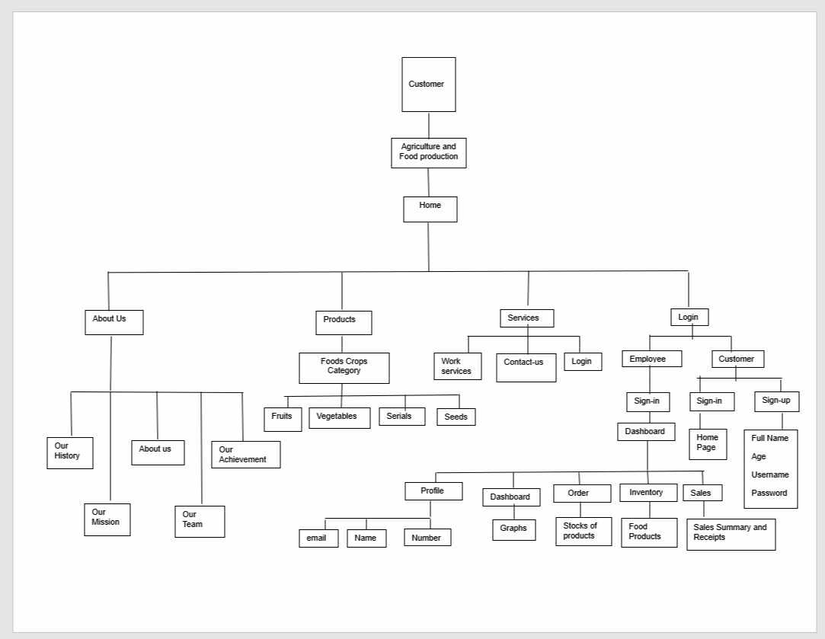

**SITE ARCHITECTURE**

***NAVIGATION MENU***

Greetings from Agriculture and Food Production, your go-to resource for sustainable farming and food preparation methods. Explore our selection of services that are intended to improve food processing, advance ecological sustainability, and maximize farming techniques.

**1.** **Home**

In the home part, various products, projects, advocacy, opportunities and livestocks of our company can be seen. This was done to see at a glance what our company can do.

**2.** **About**

We have done agriculture and food production in order to supply various agricultural products and tools such as vegetable foods, fruits, plants and others. We also created this website to make it easier for them to get their needs when they want to get something that is difficult to get in their area.

**3.** **Mission and Values**

· Our goal is straightforward but profound: via ethical farming, we want to build a sustainable future. Driven by our fundamental principles of honesty, ecological responsibility, and neighborhood cooperation, we endeavor to deliver healthy food while maintaining the fragile equilibrium of the natural world.

**4.** **Products**

Fresh Vegetables: Our fresh produce, which ranges from colorful heirloom tomatoes to crunchy organic lettuce, is a testament to the abundance of our rich soil. Discover our wide selection, which is expertly gathered and supplied when it's still as fresh as possible.

Prepared Foods: Visit our processed foods area to learn about the craft of food transformation. Every product, from delicious sauces to artisanal jams, is expertly made to guarantee a taste explosion with every bite.

Specialty Items: Use our unique goods to enhance your cooking experience. Unique offers, uncommon herbs, and carefully chosen spices give your kitchen a hint of exclusivity.

**5.** **Services**

* · **Contact Us**

Information to Contact: You can reach us with only a click if you have any questions or just want to say hi. Contact us via our phone, or by email.

* · **Social Media Integration**

Join us on the social media platforms. For up-to-date information, interesting articles, and a community of people who share your enthusiasm for sustainable agriculture, follow our profiles.

**6.** **Login or Sign Up**

The user accounts can be managed using these options. To use account features like wish lists, purchase histories and saved searches, users must register. To open a new account, users must sign up.

**7.** **Profile**

In the Profile section, the User's Email, Name and Contact Number can be found

**8.** **Dashboard**

In the dashboard part, you can see the graphs that show the sales results of our company to know its sales in the past months.

**9.** **Orders**

In the orders part, you can see the different products of our group where different vegetables, fruits and plants can be seen here

**10.** **Inventory**

In the inventory part, we can see the different food products of our company, here we can also see the stocked foods such as vegetables, fruits, herbs and others

**11.** **Sales**

In the sales part, we can see the income of the products we sell such as vegetables, fruits, plants and others in the past months to maintain its good flow

***SITEMAP***

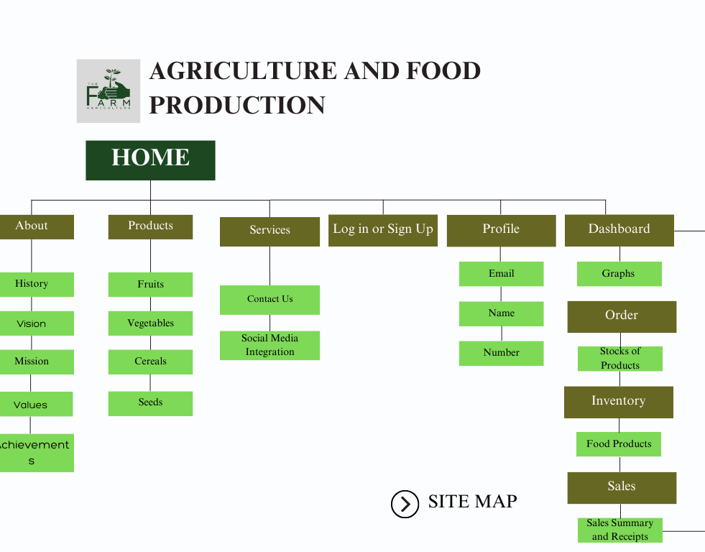

**DESIGN AND LAYOUT**

A website such as The Farm Agriculture website showcases the spirit of nature and cultivation, utilizing a balanced color palette of brown and green. The warm brown hues signify the fertile soil and the fundamental aspect of our farming practices, while the lively greens depict thriving crops and the bountiful gifts of nature. Our website features a carefully curated interface that not only offers a visually pleasing experience but also underscores our dedication to sustainable farming and the production of wholesome food. Navigating the site is akin to strolling through a vibrant farm, where each click reveals the narrative of conscientious cultivation and the journey from field to table.

delving into the typography and layout elements of our agriculture and food production website. The choice of a sans-serif font exudes modernity and clarity, aligning with our commitment to transparent communication. The clean lines and absence of decorative flourishes in the typeface enhance readability, ensuring that visitors can easily absorb the wealth of information we provide.

Furthermore, our commitment to a user-friendly experience is reflected in the rounded corners of every box and element on the site. This design choice not only adds a touch of approachability but also contributes to a seamless visual flow, inviting users to explore different facets of our offerings. The rounded edges soften the overall aesthetic, creating a welcoming digital environment that mirrors the organic, natural feel of our agricultural practices. As visitors navigate through the website, the combination of sans-serif typography and rounded corners creates a harmonious balance between modernity and warmth.

The Logo has its hand symbol with a crop with it that symbolizes, giving more opportunities to people with farmland to maximize the resource they have. The symbol also uses green and cream color scheme to make it simple and aesthetically pleasing to the viewer.

In conclusion, The team aims for a user friendly website while making it aesthetically pleasing and not difficult for the user to navigate all though out of it, we also make the Typography bigger since because we base it to our elders who are slowly adapting to the new technology and needs to read carefully all through out the websites content